**Abstract**

**Noise pollution is unwanted sound, it needs to be controlled to make the workplace comfortable. This chapter analyses noise mathematically and the effects of multiple sources are examined. Two noises of exactly the same level can have a combined noise level that is 3 dB higher than the individual values. The greater the difference between the two individual noise sources, the lower is the combined noise level. Different people react differently to the same type of noise. A noise level up to 90 dB does not have any appreciable effect. Exposure in excess of 115 dB is not permitted with unprotected ears as it runs the risk of hearing impairment. The average noise level of various equipment used inside the washery generally ranges from 85 to 110 dB. Various control measures for the abatement of noise pollution have been studied. The hierarchy of control for a reduction of hearing loss to personnel is illustrated.**

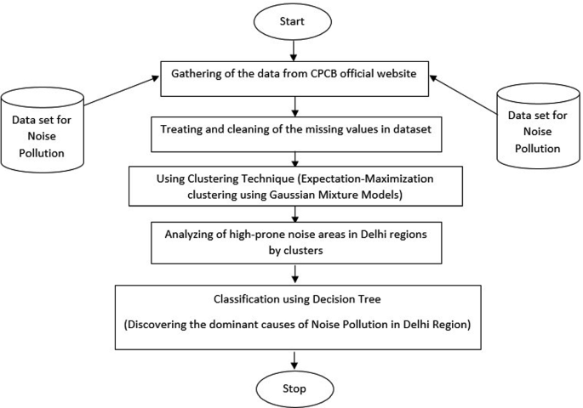

***Noise Pollution Monitoring***

* A 20-foot-wide plantation inside the property isolates the house from the noise of moving vehicles.
* Putting in place acoustic zoning, which involves dividing populous areas from noise-producing areas like airports, train stations, and other industrial facilities. Silence zones should be established in hospitals, schools, and essential offices.
* Safety gear like cotton plugs or ear muffs should be provided to employees working on noisy projects.
* Noise pollution from air traffic can be reduced with the right insulation and noise introduction.
* Airport takeoff and landing regulations.
* Power tool use at night, loud music, land movers, loudspeaker use at public events, etc., should all be forbidden. It is forbidden to utilize appliances—such as horns, sirens, and refrigerators—excessively. Avoid using too many noisy, air-polluting firecrackers.
* By planting a lot of trees to create buffer zones that are covered in flora and absorb noise.
* It’s important to keep musical instrument noise within appropriate limits.

|  |  |  |  |  |
| --- | --- | --- | --- | --- |
| Location | Highestvalue | Lowestvalue | Average(db) | StdDev+or- |
|  |  |  |  |  |
| Chennai Merina | 80.6 | 64.5 | 72 | 78.4 |
| MarineLines | 80.3 | 54.3 | 34.3 | 70.3 |
| charniRoad | 82.5 | 87.3 | 78.01 | 72.4 |
| Mumbaicentral  (tardo) | 91.4 | 23.5 | 23.34 | 99.4 |
| HajiAli | 84.3 | 62.3 | 43.3 | 103.2 |
| Mahalakshmi | 84.2 | 78.9 | 23.3 | 104.2 |
| Dr.E.MosesRoad | 94 | 33.2 | 67.3 | 99.3 |
| OMR | 86.6 | 67.4 | 34.8 | 70.4 |
| lighthouse | 104.2 | 33.5 | 98.3 | 22.3 |
| Guindy | 78.3 | 22.9 | 109.3 | 65.3 |
| Saidapet | 62.9 | 99.1 | 64.3 | 98.4 |
| koyambedu | 43.2 | 211.3 | 45.3 | 55.4 |
| Thenapet | 64.9 | 106.4 | 98.6 | 22.4 |
| MountRoad | 50.9 | 54.3 | 54.2 | 54.3 |
| Meenambakkam | 78.4 | 78.4 | 99.01 | 22.3 |
| Thirisulam | 65.8 | 89.4 | 63.2 | 24.9 |
| Pallavaram | 45.3 | 34.2 | 44.3 | 34.5 |
| Pazhavanthangal | 43.7 | 34.2 | 45.4 | 23.7 |
| Egmore | 89 | 89.3 | 67.4 | 87.4 |
| Chennaicentral | 55.7 | 76.3 | 22.3 | 66.5 |
| kodambakkam | 65.9 | 23.01 | 98.4 | 8.5 |
| Nungambakkam | 33.4 | 43.3 | 88.3 | 102.4 |
| Chethpat | 76.9 | 102.3 | 67.3 | 87.2 |
| Mambalam | 22.4 | 112.4 | 78.3 | 99.5 |

|  |  |  |  |  |
| --- | --- | --- | --- | --- |
| StdError | Varience | Leq | Nc | Lnp(NPL) |
| 77.3 | 23.3 | 45.3 | 104.5 | 67.3 |
| 56.3 | 43.3 | 34.6 | 90.1 | 30.2 |
| 32.4 | 67.3 | 87.5 | 30.4 | 90.23 |
| 55.4 | 104.2 | 90.5 | 35.67 | 67.3 |
| 66.4 | 64.2 | 45.3 | 89.2 | 45.32 |
| 98.4 | 67.3 | 89.4 | 88.33 | 78.34 |
| 32.5 | 11.2 | 90.4 | 45.9 | 66.34 |
| 56.2 | 108.3 | 85.3 | 33.22 | 12.45 |
| 88.3 | 56.3 | 46.7 | 10.3 | 98.57 |
| 87.2 | 88.3 | 102.5 | 56.3 | 87.33 |
| 45.3 | 22 | 105.3 | 29.4 | 55.1 |
| 86.4 | 87.3 | 78.4 | 68.44 | 108.2 |
| 99.4 | 98.3 | 13.45 | 78.34 | 139.3 |
| 99.3 | 199.3 | 90.3 | 108.3 | 78.22 |
| 88.3 | 178.3 | 99.3 | 45.2 | 64.23 |
| 22.3 | 67.3 | 78.3 | 46.2 | 78.33 |
| 77.8 | 34.1 | 90.2 | 78.4 | 33.22 |
| 45.6 | 98.5 | 89.3 | 26.2 | 89.45 |
| 107.3 | 102.5 | 44.3 | 90.3 | 46.34 |
| 66 | 56.2 | 23.5 | 23.4 | 78.3 |
| 77.4 | 87.4 | 90.4 | 90.28 | 33.44 |
| 64.2 | 98.4 | 45.7 | 45.67 | 90.33 |
| 54.2 | 32.4 | 78.4 | 104.8 | 66.3 |
| 12.4 | 90.4 | 87 | 104.6 | 78.5 |

**PROGRAM**

<!DOCTYPE html>

<html>

<head>

    <title>Noise Pollution Monitoring</title>

</head>

<body>

    <header>

        <h1>Noise Pollution Monitoring</h1>

    </header>

    <section>

        <h2>Real-time Noise Data</h2>

        <p>Monitor noise levels in your area.</p>

        <div id="noise-data">

            <!-- Real-time noise data will be displayed here -->

        </div>

    </section>

    <section>

        <h2>Threshold Alerts</h2>

        <p>Set noise level thresholds and receive alerts.</p>

        <label for="threshold">Set Threshold (dB):</label>

        <input type="number" id="threshold" min="0" step="1">

        <button id="set-threshold">Set</button>

        <p id="alert-message"></p>

    </section>

    <footer>

        <p>&copy; 2023 Noise Pollution Monitoring System</p>

    </footer>

    <script>

        // JavaScript code for real-time data retrieval and threshold alerts

        // You need to implement this part separately.

        // It would involve audio streaming, data analysis, and notifications.

    </script>

</body>

</html>

**OUTPUT**

**Noise Pollution Monitoring**

**Real-time Noise Data**

Monitor noise levels in your area.

**Threshold Alerts**

Set noise level thresholds and receive alerts.

|  |
| --- |
| Set |

Set Threshold (dB):

© 2023 Noise Pollution Monitoring System